**PSG COLLEGE OF TECHNOLOGY, COIMBATORE – 641 004**

**DEPARTMENT OF COMPUTER APPLICATIONS**

**Academic Year 2023-2024 MCA G1 - Semester 1**

**23MX18 WEB APPLICATION DEVELOPMENT**

**Design Document**

**I. Team Detail**

| **Batch No.** | **Roll No.** | **Name of the student** | **Name of the Faculty Guide** |
| --- | --- | --- | --- |
| 4 | 23MX103 | Aparna Ramanathan | Dr.S.Bhama |
| 23MX120 | Nivetha S |
| 23MX128 | T Varadharajaperumal |

**II. Title of the Application**

| Charitable - A new way to charity |
| --- |

**III. Abstract (at least 200 words)**

| This web application is intended to bridge the gap between a donor and a beneficiary by providing a platform to donate goods online. This website will connect two people based on their mutual needs and without involvement of any financial transactions – purely appealing to the innate charitable quality within each to donate, while encouraging other persons to avail of the opportunity that could make a huge difference in their quality of life. Traditional methods involve donors approaching established organisations, and are dependent on them to facilitate their donations to the needy. Here, we provide a platform to directly connect donors and beneficiaries facilitating independent donation/acceptance of commodities to take place. Providing a platform as this is in itself a great opportunity for ‘we the team’ to do our bit for the social cause that can benefit humanity in the long run. |
| --- |

**IV. Existing System (if any)**

**SADS (Share At Door Step):** SADS is an organisation that lets people donate from their doorstep. Most donors, oftentimes don’t have the time and inclination to make an effort to find a trustworthy NGO and thereby end up throwing away perfectly usable goods. To prevent this needless waste of useful resources, SADS website lets a user book a pick up time, and the organisation members come and collect the goods right at their doorstep to further pass it on to trustworthy NGOs.

**V. Proposed System**

**Charitable - A new way to charity:**  Most organisations working in this field act as an intermediary between donors and NGOs, whereas the Charitable website will directly connect donors and beneficiaries without involvement of any kind of intermediary organisations or middlemen.

This web application will facilitate people to directly donate/avail commodities with a single click. Donating will become an easier task, not to mention the convenience of donating without even stepping out of one’s house. From the beneficiary’s point of view too, this platform enables them to instantaneously find donors and helps them to procure an item that they may need in a short span of time. In technical terms the proposed system is an interface/platform open to all users to donate and avail all kinds of products.

**VI. Objectives of the Proposed Application**

| * Provide a platform to cultivate and encourage charity and generosity as a means of social service. * Connecting donor and beneficiary directly without middlemen * Easy and complete access to all users * Web site services will be free and open to all with no commercial intentions. |
| --- |

**VII. Scope / Use**

| * Any user with a device and internet access * Any user with the goodwill to donate * Any user with a genuine requirement for goods |
| --- |

**VIII. Technology to be used (Specific Framework etc.)**

| Front end: HTML, CSS, JS, Bootstrap  Back end: JS  Database:MYSQL |
| --- |

**IX. Functional Requirements of the Application**

| * For the general public:   + Displaying items and their details   + Providing a window for login * For the donor:   + Providing a page to post their product descriptions * For the beneficiary:   + Viewing items and their details   + Booking the selected item   + Providing a page to post their needs   + Provide a feedback mechanism to resolve issues/improve service. |
| --- |

**X. Non-Functional Requirements of the Application**

| * Providing a highly interactive and user friendly interface. * Providing a friendly user experience that lets even a novice user navigate through the website easily. * Making sure that the website is scalable. * Making sure that the website is compatible and runs on all different browsers and devices. |
| --- |

**XI. Flow diagram of the Application (CAD/ Flowchart/ DFD kind of diagram to illustrate the flow of your application)**

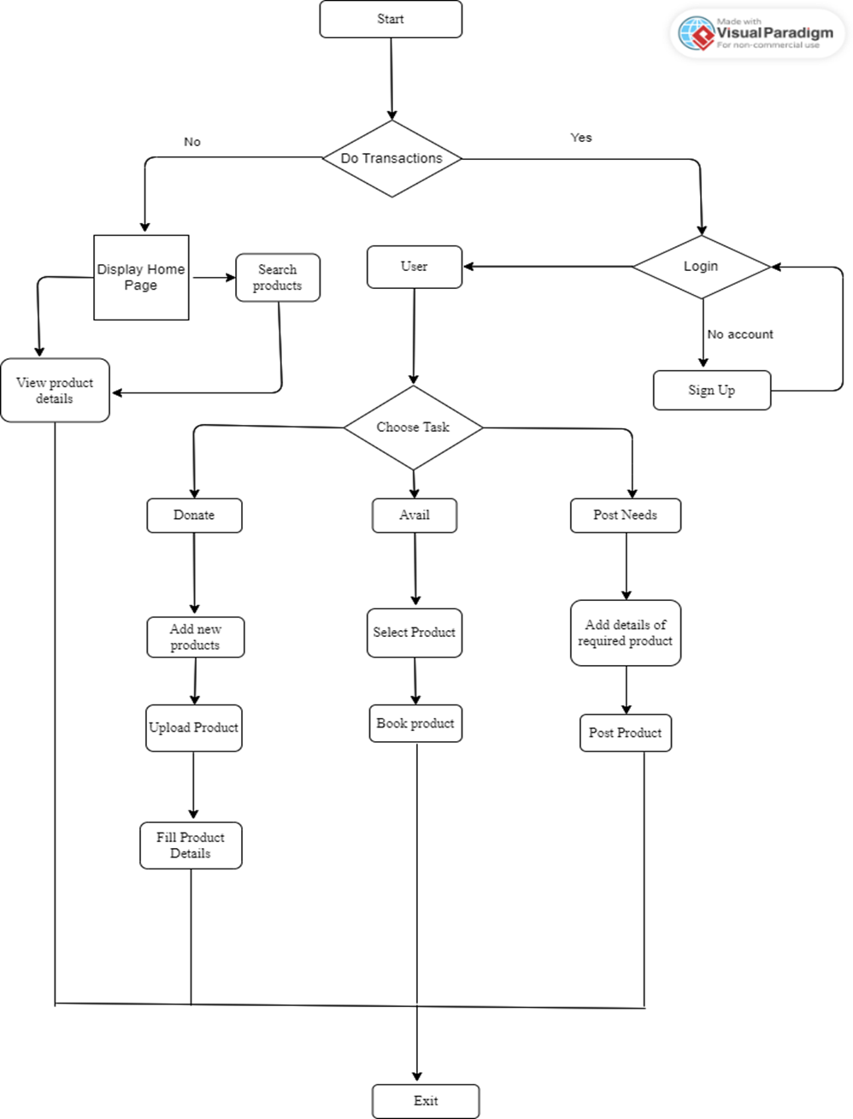

**XII. Interface/prototype of the proposed Application (use Storyboarding method / Wireframe tools to do this….)**

* **Home page before and after login:**

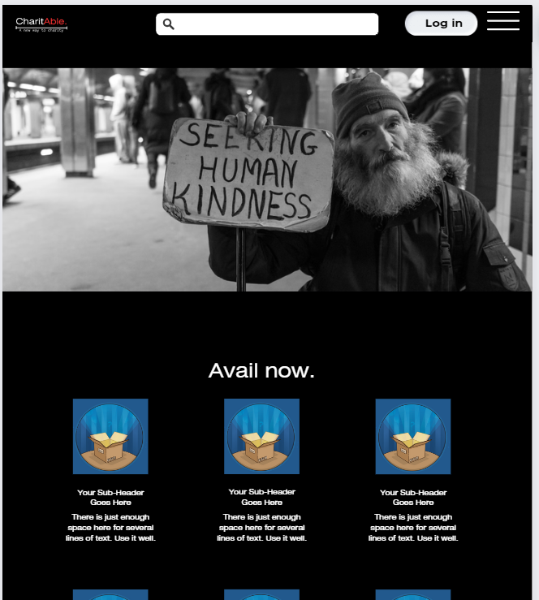

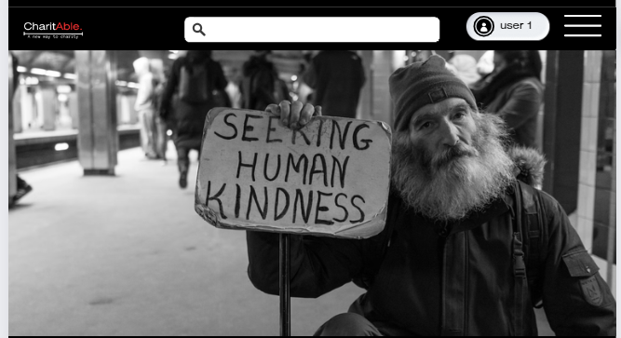

* **Product display page:**

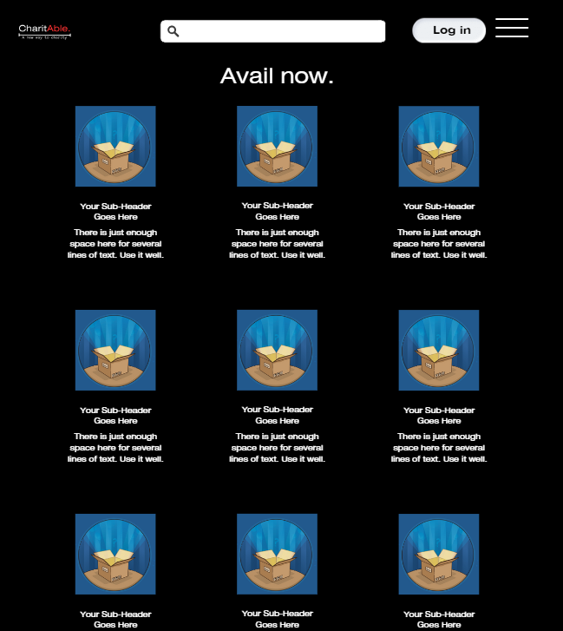

* **Selected product page:**

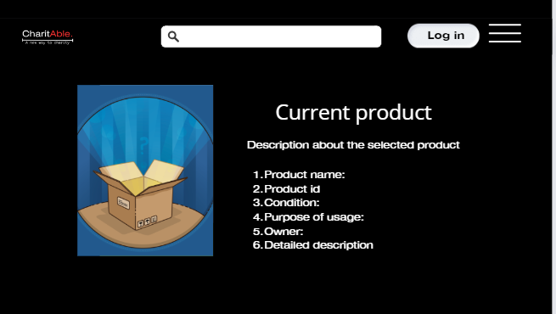

* **Product posting page:**

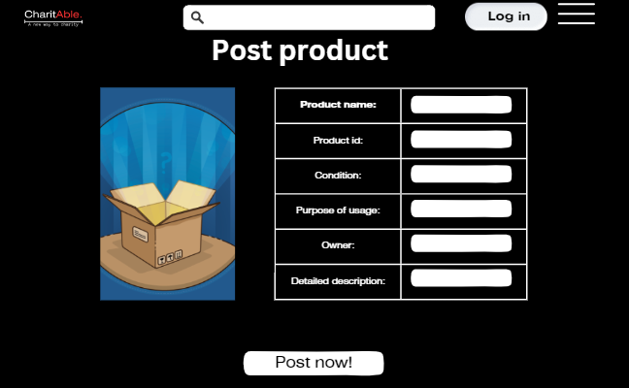

* **Posting needs page:**

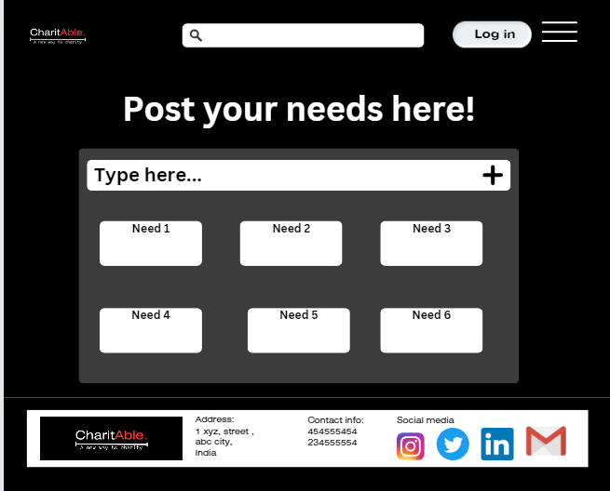

**XIII. Database schema :**

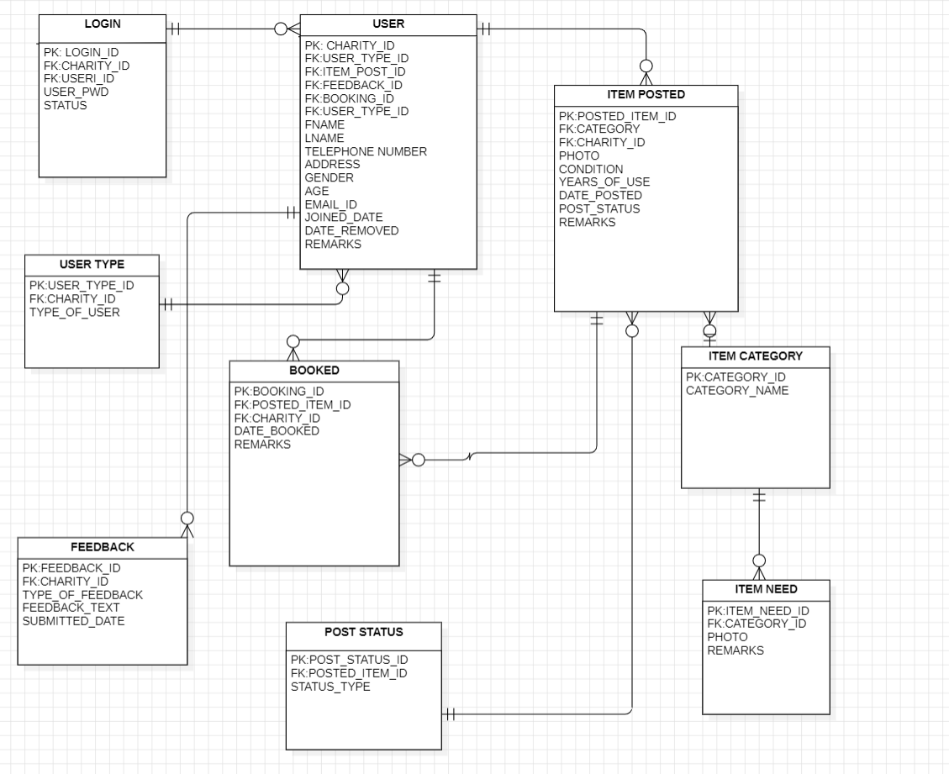

**XIV: Use Case Diagram for the application:**

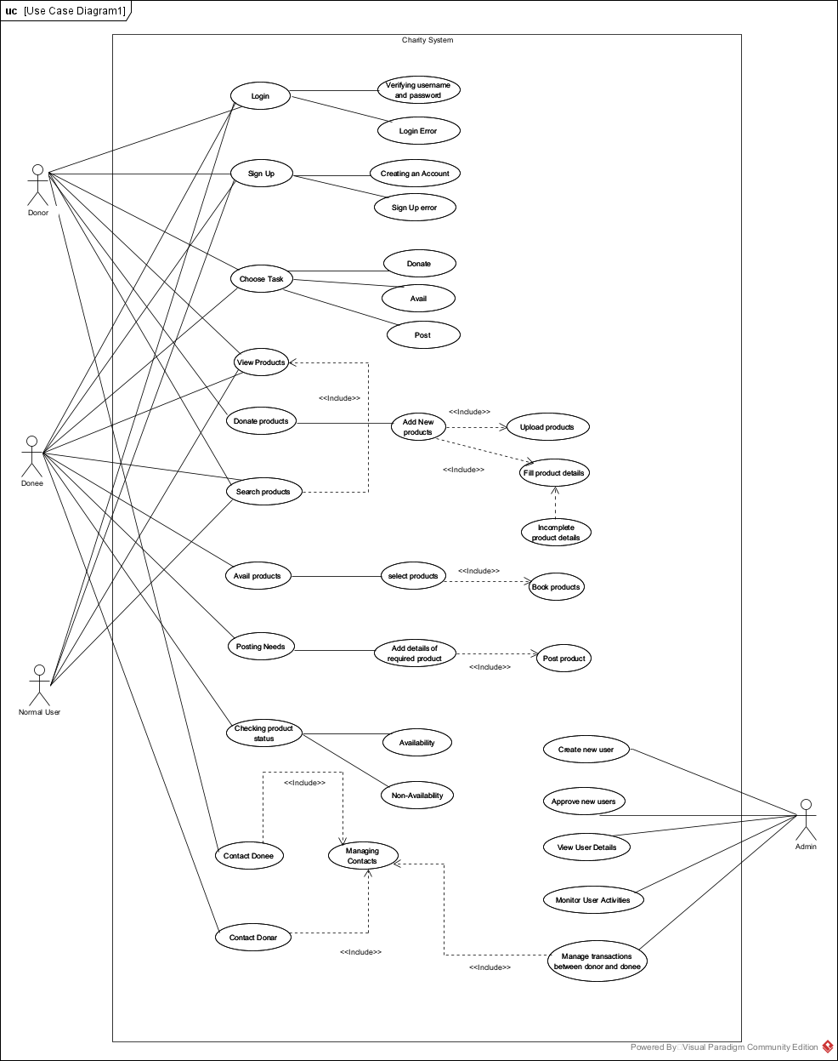

**XV: Other specifications/diagrams related to your work:**

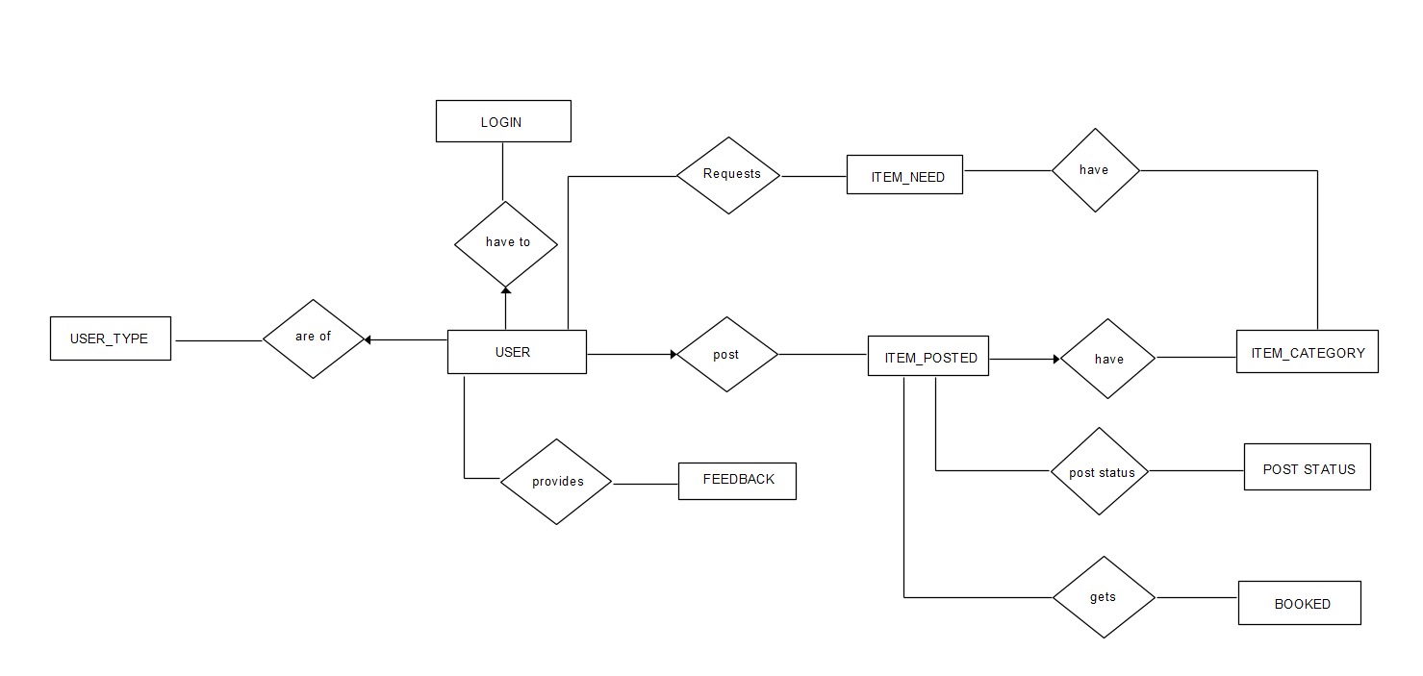

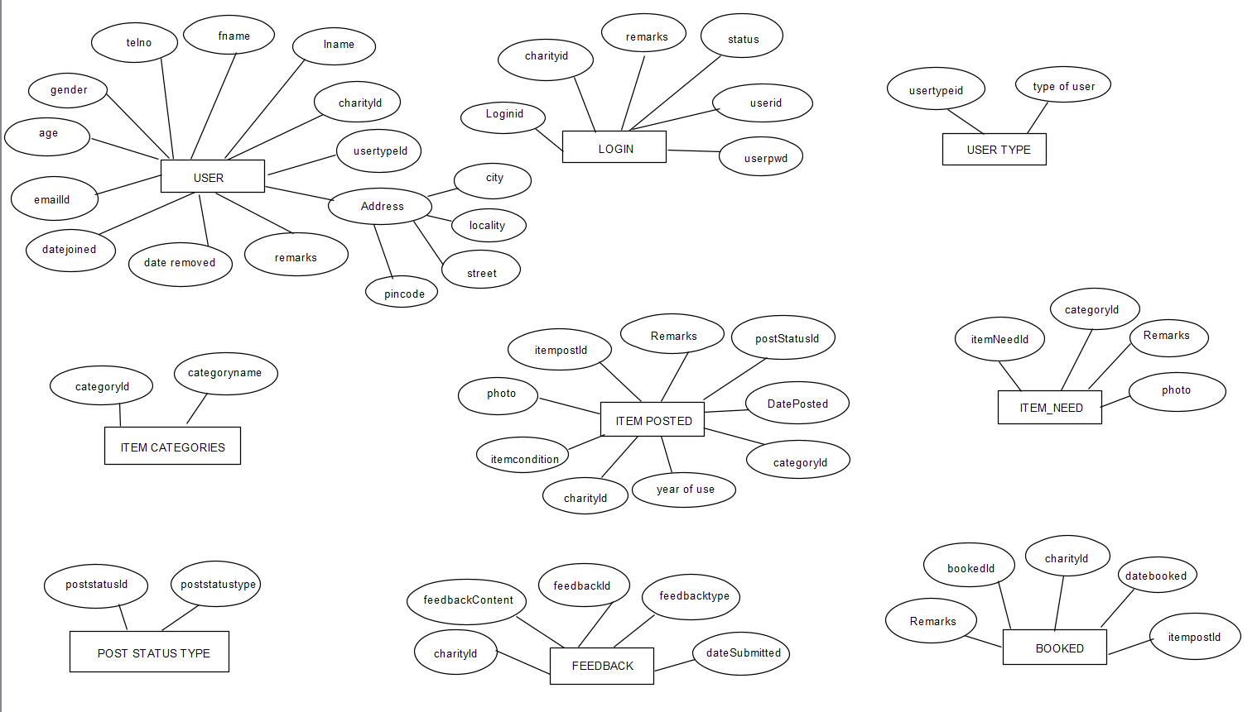

**XVI: Timeline of Activities planned/completed**

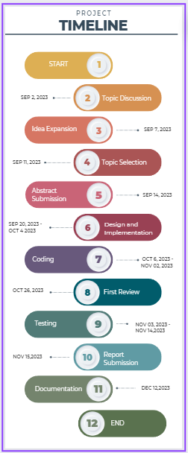

**Signature of the students Signature of the Guide**

**Name 1: Name:**

**Name 2:**

**Name 3:**